Elior Bilow
Recitation 3 Problem – TRISO Uranium Pellets
MEGN471 – CSM
2022-02-07

Study focused on in this problem: Terrani et. al. “Uranium nitride tristructural isotropic fuel particle.” Oak Ridge National Laboratory. Feb 4, 2020. https://www.osti.gov/biblio/1606770

Introduction:
The biggest risk involved with nuclear power plants is meltdowns. To decrease this risk, a form factor of reactor fuel was invented in the 1950s and has been continuously developed to this day. This form factor is called TRISO (short for TRI-structural ISOtropic particle fuel). This fuel comes in the form of small spherical pellets smaller than a poppy seed. The fuel particle has a uranium compound in its core (called a kernel) which is surrounded by various protective layers (usually including graphite and silicon carbide).
In this study, we’ll be investigating a study done by Terrani, Jolly, and Harp at the Oak Ridge National Laboratory. They used a uranium-nitride kernel surrounded by a buffer layer, then a protective carbon layer (called the internal pyrolytic carbon layer or IPyC), then a silicon-carbide layer (SiC), then an outer protective carbon layer (OPyC). A cross section of the pellet can be seen in figure 1.
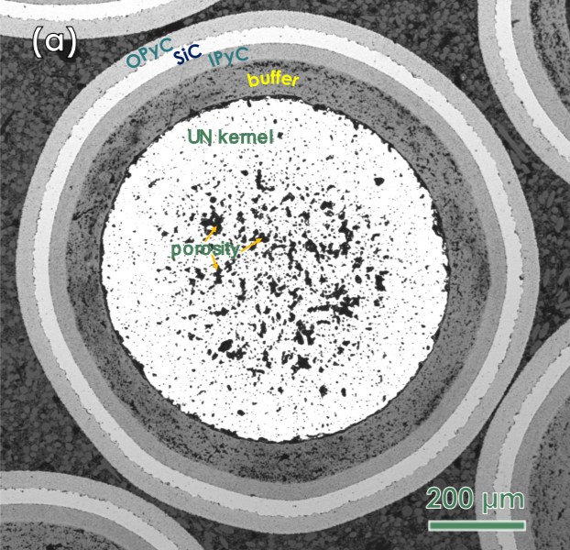
Figure 1: Cross section of a TRISCO particle. Source: Oak Ridge National Laboratory.
For this problem, assume the following properties:
Layer | Size (μm) | Thermal conductivity (W/(m*K))
Kernel | 800 (diameter) | 3.8
Buffer | 90 (layer thickness) | 0.5
IPyC | 35 (layer thickness) | 4.0
SiC | 35 (layer thickness) | 168
OPyC | 35 (layer thickness) | 4.0
Source for thermal conductivity: Jiang et. al. “Fission Product Transport in TRISO Particles and Pebbles.” Idaho National Laboratory. 30 June 2021. https://inldigitallibrary.inl.gov/sites/sti/sti/Sort_47414.pdf
Property | Specification
Surface temperature (ºC) | 1800
Kernel heat generation (GW/m³) | 2.03

Questions:
Assume steady-state for this problem.
1. Draw a thermal circuit diagram for this system starting with the buffer layer and ending with the OPyC layer.
2. What is the thermal resistance of the buffer layer, the IPyC layer, the SiC layer, and the OPyC layer?
3. What is the total power generated by the kernel?
4. What is the temperature at the kernel-buffer interface?
5. What are two boundary conditions for the kernel?
6. What is the heat diffusion equation (HDE) for the kernel?
7. What is the temperature at the center of the pellet?

